


Coccyx Pain

Service User
Information Leaflet

Produced by: Pelvic Health Physiotherapy Service

Date of issue: Sep 2020 Review Date: Sep 2022

NHS Fife provides accessible communication in a variety of formats including for people who are speakers of community languages, who require Easy Read versions, who speak BSL, read Braille or use Audio formats.

NHS Fife SMS text service number 07805800005 is available for people who have a hearing or speech impairment.

To find out more about accessible formats phone 01592 729130 or contact: fife.equalityandhumanrights@nhs.scot.

Aim of Leaflet
The aim of this leaflet is to provide some basic information on your condition and some self help advice.

Anatomy
The coccyx is otherwise known as the tailbone and sits at the very bottom of the spine. It is made up of a few bones that have become fused together. It is attached to the bottom of the sacrum bone and sits within the pelvis. Structures attached to the coccyx include the pelvic floor muscles, part of the buttock muscles and ligaments.

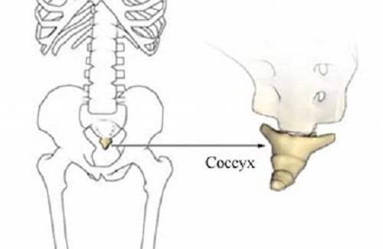

Injury
The coccyx can become injured or painful from:
- A fall, landing on your bottom. E.g. slip on ice, fall from horse, missing a chair when sitting down.
- Childbirth
- Repetitive strain
- Being over or under weight
- Surgery

A painful coccyx is known as coccydynia.

Symptoms of Coccydynia
- Pain during or after sitting
- Acute pain when getting up from sitting
- Deep ache around the coccyx (between the buttocks)
- Tenderness on pressing the tip of the coccyx
- Pain during daily activities such as bending and those which include sitting e.g. driving, office work or relaxing on the sofa
- Shooting pains
- Like sitting on a marble
- Pain during sexual intercourse
- Pain during a bowel movement or when the bowel is full

Self Help
There are a number of treatment options which may help to reduce the symptoms. Simple self help measures you can try at home are recommended first. These are:
- Ice or Heat
- Anti-inflammatory medication as recommended by the pharmacist / GP
- Activity modification such as avoiding sitting for too long and utilising towels/cushions as demonstrated on the next page.
- Manage constipation i.e. Increase fluid and/or fibre intake. If necessary laxatives as recommended by the pharmacist.
- Wear loose clothing.

Treatment
Treatment is often not started quickly as patients wait for the pain to disappear by itself, or health care professionals might delay onward referral in the hope it will settle by itself. Treatment can be prolonged and the pain can take a long time to settle down.
Some simple remedies can help. Try the self-help suggestions above. Other treatments include injection of anti-inflammatory and steroid, manual treatment and surgery to remove the coccyx.

Physiotherapy
Specially trained physiotherapists can assess and treat coccyx pain. Once any other cause for the pain has been excluded such as lower back problems. The physiotherapist may give you advice on posture, movement, exercises and stretches. They may also use manual therapy and taping to treat the local problem. Manual therapy can include mobilising the coccyx, either externally or sometimes internally via the back passage. This usually provides good relief from the symptoms. The physiotherapist can also assess the muscles and soft tissue next to the coccyx and treat these if they are the cause of the pain.

Sitting
One of the most important things you can do to help your pain is to change the way you sit, or avoid it all together where possible. Try not to sit on ‘one cheek’ as this places strain on the rest of your body.

Sitting places a great strain on the coccyx (see diagram courtesy of www.backintellegence.com)

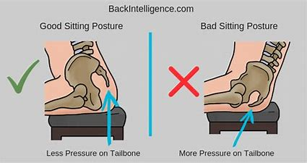

By leaning forward on your thighs while sitting, the pressure on your coccyx will be reduced. It is also recommended that you use 2 towels, rolled up and placed in a V shape with the point at the front of the seat to sit on. Place your ‘seat bones’ on the towels and this should ensure your coccyx remains free of pressure at the back in the opening of the V. Check you can get your hand under your bottom at the back! Use these towels at home, work, socially, in the car or wherever you need to sit down.

Reference
www.coccyx.org

