You must be prepared to complete the full course of treatment.

It is advisable to attend sessions wearing comfortable loose trousers/skirts that facilitate the application of the laser treatment.



SAFETY

Most people are suitable for low level light therapy. Your Podiatrist will advise you of your suitability.

NHS Fife provides accessible communication in a variety of formats including for people who are speakers of community languages, who require Easy Read versions, who speak BSL, read Braille or use Audio formats.

NHS Fife SMS text service number 07805800005 is available for people who have a hearing or speech impairment.

To find out more about accessible formats contact:
fife-UHB.EqualityandHumanRights@nhs.netor phone 01592 729130

Further patient information leaflets are available online on our website www.nhsfife.org/

Fife Council and NHS Fife
are supporting the people
of Fife together through
Fife’s Health and Social
Care Partnership.
www.fifehealthandsocialcare.org

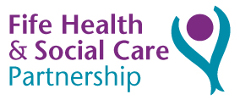

Issued | Jan 2002
Revised | Sept 2019
Next Review | Sept 2021
Images | NHS Podiatry

PODIATRY
DEPARTMENT

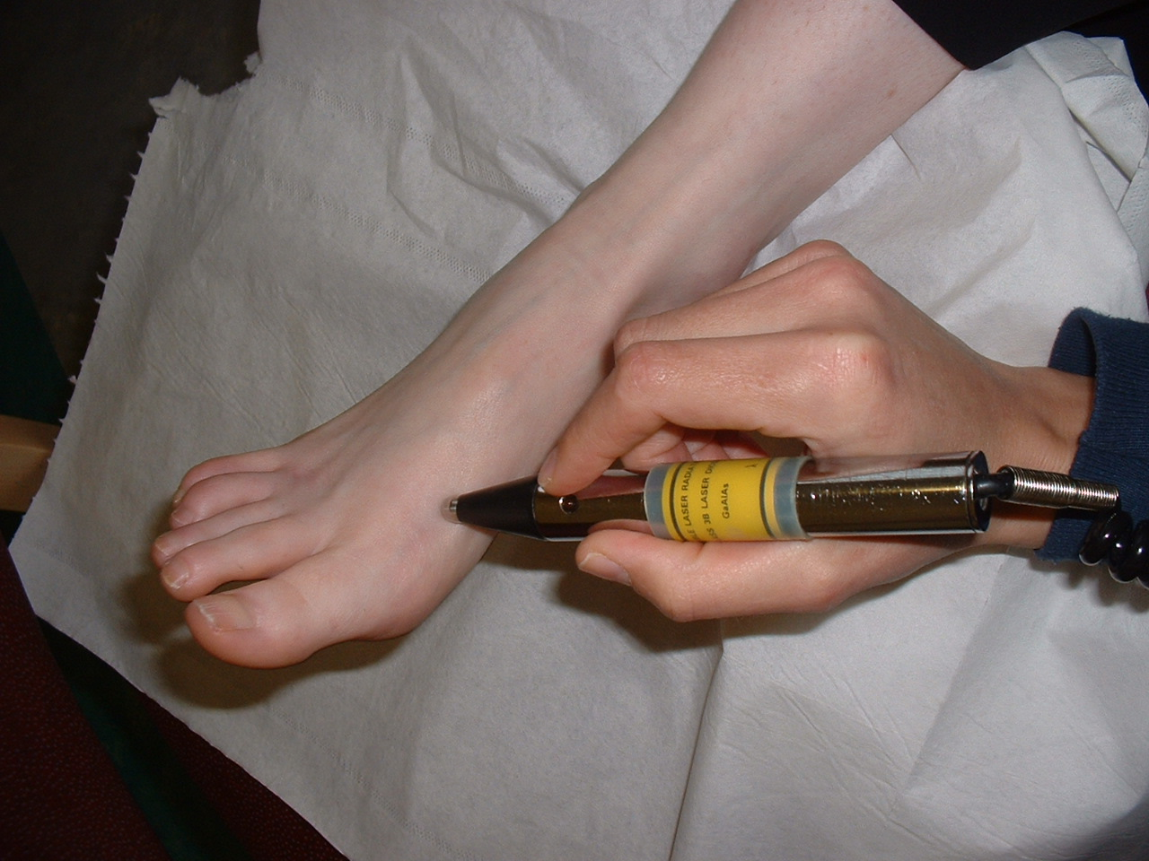

LOW LEVEL LIGHT THERAPY (LASER)

WHAT IS LASER THERAPY?

Laser therapy uses low power laser light to aid the natural healing process of the body safely and effectively, by reducing inflammation and stimulating healing.

Conditions which may benefit from Laser therapy

- Heel pain/ plantar fasciitis
- Tendonitis
- Painful muscle and ligament conditions in the foot and ankle

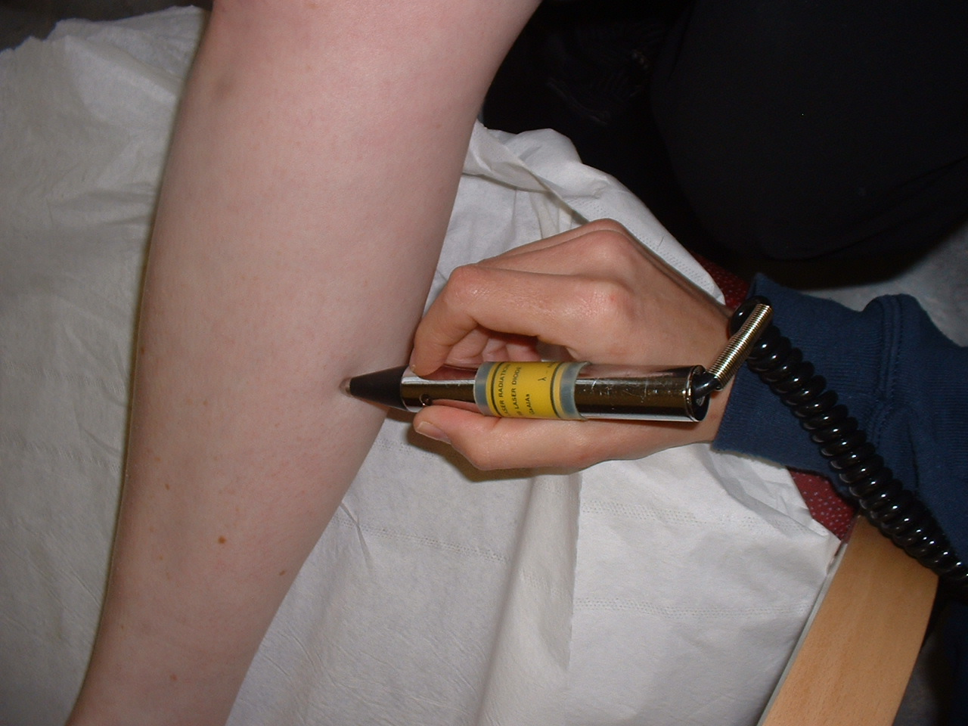

HOW DOES IT WORK?

Particles of light stimulate the body’s healing cells. By directly treating the damaged tissue with appropriate light, laser helps the body to heal itself and reduce pain.

Can anyone have Laser Treatment?
Low level laser therapy is best avoided if you are:
- Pregnant
- Have Cancer
- Have had an Organ transplant
- Have had a steroid injection in the last 4 weeks.
- Have a pacemaker
- Have tattoos on the area to treat.

THE TREATMENT

A probe is held on the skin in several locations:
- On the lymph node at the back of your knee.
- On the area(s) where you are experiencing problems.
- On the trigger points of your calf muscle.
- On the lower back.
Depending on the condition each probe is in place for a period varying from 30 seconds to several minutes.

A special pair of goggles must be worn at all times to protect the eyes.

The treatment is usually carried out twice a week for 6 weeks.
It is quick and pain free. You may feel some warmth or tingling in the area.
Sometimes there may be an initial increase in discomfort following treatment. This should subside within a few hours.

