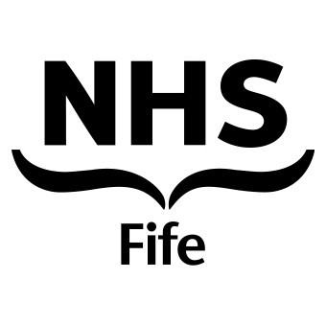
Department of Dermatology
Fife Acute Hospitals NHS Trust, Queen Margaret Hospital

GUIDELINES FOR PATIENTS
WHO HAVE HAD A LESION REMOVED
BY CURETTAGE

1 It normally takes 1 - 2 hours for a local anaesthetic to wear off. Take two tablets
of Paracetamol or a similar painkiller if required. Do not take Aspirin or
Ibuprofen as this encourages bleeding.

2 If a dressing has been applied keep it on for 24 to 48 hours then leave the area uncovered.

3 Keep the area treated dry for 24 hours. Application of white soft paraffin/vaseline before & after a shower protects the wound and acts as a waterproofing barrier.

4 After washing the area pat it dry but do not rub it actively.

5 Do not scratch the area, this may introduce infection.

6 If the scab is knocked and the area starts to bleed apply pressure until the
bleeding ceases.

7 If the area becomes red, swollen or painful after 48 hours, see your own GP as
an infection may need treatment.

8 The scab may take 2 - 3 weeks to fall off, don't pick it off.

9 If the curettage procedure was on the face or the neck, do not use make-up on
the area until it has healed.

10 If a sample has been sent to the laboratory, your GP should receive the result
within 3 - 4 weeks of the procedure.

/tmp/in/input.doc

