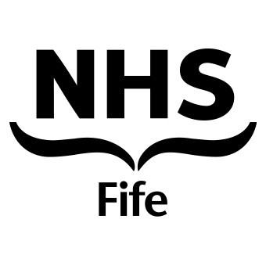
Department of Dermatology
Fife Acute Hospitals NHS Trust, Queen Margaret Hospital

PATIENT INFORMATION LEAFLET

CRYOTHERAPY is a carefully controlled cold burn which is administered by the application of liquid nitrogen to the skin, either using a cotton wool bud or a spray technique.

The actual procedure may be painful depending on the length of the freeze and the area being treated.

- After treatment, redness of the skin and swelling will develop.
- On occasion this may result in blister formation either water filled or blood filled blister.
- If the blister does form, let the fluid out with a sterile needle and apply a clean dry dressing.
- If the area treated becomes inflamed, an antiseptic cream such as Germolene or Savlon can be applied.
- After the procedure you will develop some crusting on the surface of the skin which will separate in a view days.

If discomfort or pain occurs after treatment, Paracetamol 1 - 2 tablets two to three times a day will help.
If there are any concerns or issues regarding your treatment, please consult your General Practitioner or contact the Nurse in Charge, Ward 15, Queen Margaret Hospital, Dunfermline.

 (01383) 627015, between 8 am to 7 pm, Monday to Friday

/tmp/in/input.doc

